**First Part: Test Design**

|  |  |
| --- | --- |
| Points to be tested | Priority [1 is Highest–4 is Lowest] |
| App Homepage UI | **2** |
| Adding, Editing & Deleting Records | **1** |
| Records History | **1** |
| Search Functionality | **4** |
| Calculator Operations | **3** |
| App Features (Budget planner – Carry over – Future recurring payments) | **2** |
| Unified user experience across all android devices UI & eligible versions | **3** |
| Testing App on IOS | **1** |
| Calls & Messages Interruptions | **3** |
| Impact of App usage on battery | **2** |
| Swapping between different Apps | **3** |
| Adding and Transferring Balance through accounts | **2** |
| App Data Synchronization | **3** |
| Backup & Restore | **2** |
| Exporting Data | **4** |
| Security Features (Passcode) | **1** |
| Activating Premium Feature | **1** |
| App Scaling on different screen sizes | **1** |
| Testing without Network Connection | **4** |

**Second Part: Bug Reporting**

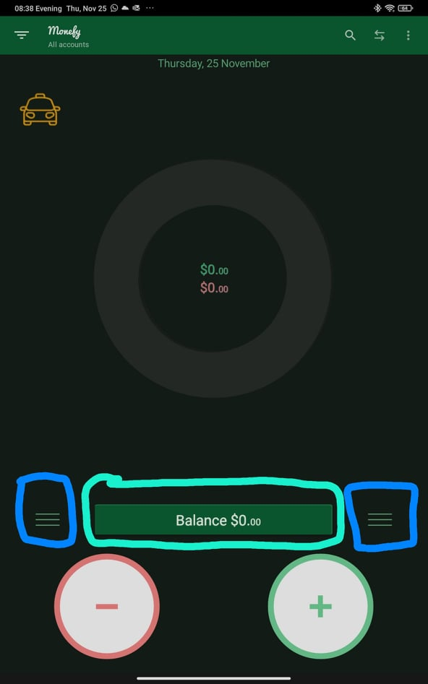3.UX Issues:

* Multiple Buttons for viewing the Records History, 2 Buttons are duplicated.
* 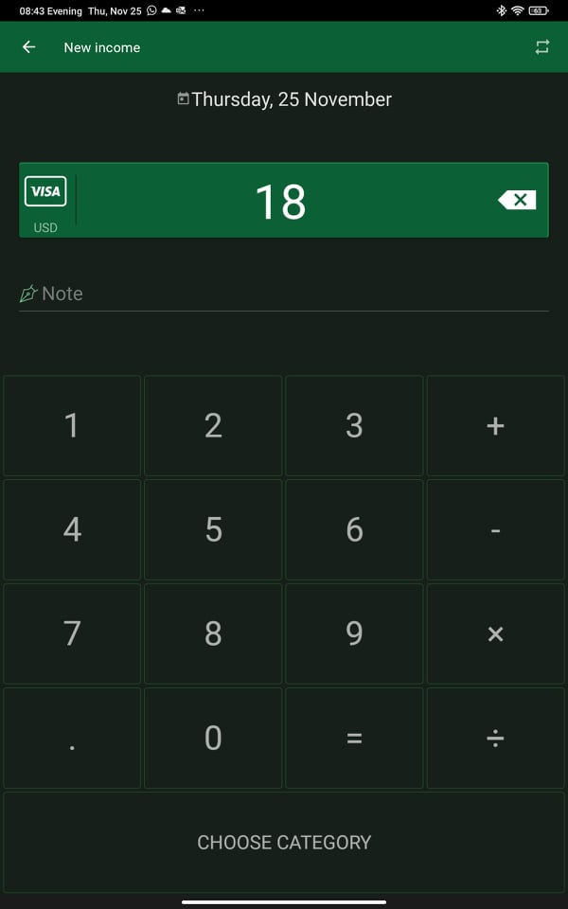Calculator does not display the calculated equations written, user has to remember his inputs to the calculator.